Neovest Remote Router Manual Update

These instructions can be used when a Neovest Remote Router has previously been installed, and the shortcut on the desktop is no longer on the desktop (deleted somehow).

From the box that the Neovest Remote Router is installed
- Go to the Windows Start menu and Select Neovest Manual Update
- If you get the Windows User Access Control Screen click (for Install UpdateGUI) -- select Yes
- You will be prompted by the Neovest Remote Router Install Screen shown below.

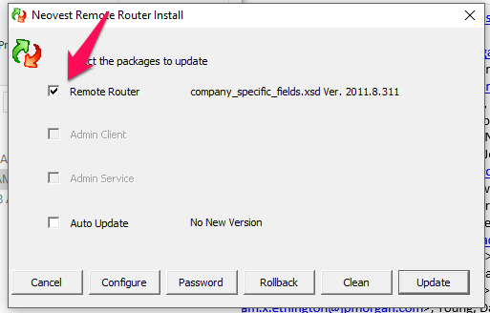

- Check the box for Remote Router –see above (if you are only installing the remote Router)
- Click Update
- You’ll see the following screen that will show the status as it updates the RRRS

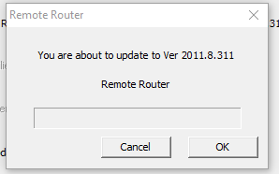

Your RRS should now be up to date.

