Neovest SDK Setup and Overview

Install JDK and UnlimitedJCEPolicy
Install the Java JDK/JRE. The current Neovest SDK version requires Java 8.
After installing your JDK, update the Unlimited Strength Java(TM) Cryptography Extension Policy Files for the Java version. This update should be made to both the JRE install directory and the JRE under your JDK install directory. You can download this for Java 8 from the link.
Copy the “.jar” files from this download into your ...jre\lib\security\
http://www.oracle.com/technetwork/java/javase/downloads/jce8-download-2133166.html

Neovest SDK
The Neovest SDK is available here: NeovestSDK
The SDK zip contains the library jar dependencies needed to use the SDK in the lib directory. The Sample programs for the various parts of the SDK are under the src directory and the Javadoc for the SDK is in the javadoc directory. There is currently no other detailed documentation on the API usage other than the Javadoc, Sample programs and the summary contained in this document.
Install the SDK samples and library jars into a project in your development environment IDE.

Obtain Neovest SDK Logins
Neovest uses 2 separate logins - the MD Login for authentication (which also includes Market Data) and the OE Login for Orders, Positions, and Targets. The MD Login is required for authentication and user settings before you are able to log into OE.

You will need to obtain these test logins from your Neovest support contact. Both these logins must be enabled for SDK usage by your support contact. You will need the username, password, domain, server and port information for the MD Login. You will need the username, password, server and port information for the OE Login.

SDK Debug Logs
If you require support for any issues you are having using the SDK, you will need to provide the associated Neovest debug log. The Neovest code writes detailed debug information to log files which help us determine any issue you are encountering. The Neovest debug log files will be located here.
Windows: %appdata%\Neovest\logs
Unix: the Neovest logs directory will be under the "user.home" directory
~/.Neovest/logs

Sample Programs
The primary sample programs are:
SampleOrderClient for new orders/targets, change orders and cancel orders.
SampleOrderTrackingClient and SamplePendingClient to monitor order states.
SamplePositionClient for Open Positions, Trade History, and Average Prices - similar to the Account+ tabs in the Neovest client
SampleQuoteClient and SampleQuoteSnapshotClient for Market Data.
SampleTargetClient and SampleTargetQueryClient for managing and monitoring targets.

Many other samples are available for specific purposes.
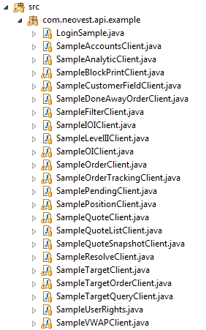

Running the Sample Programs
Each sample program in the SDK will have a section that shows how to login. The samples make use of the common LoginSample code. This will need to be edited to use your login credentials. Once the login information is edited, each sample program has a main() and can be run as a Java application from your IDE. Some of the samples will show a UI screen, others may just print output to the console.

There are 2 different methods that can be used to login. This code is in the LoginSample.java file.
Method 1 - You can copy the sdkstartup.properties file from the src\com\neovest\api\example directory and place in your program run directory. For example, in my Eclipse project the sdkstartup.properties file is placed at the same level where the src directory is located. Edit this file with your login credentials.
Method 2 - Using specific login information in the code. The sample programs show how to login with specific credentials that are hardcoded or retrieved from your application environment.
Here is an example Authentication (Market Data) login.
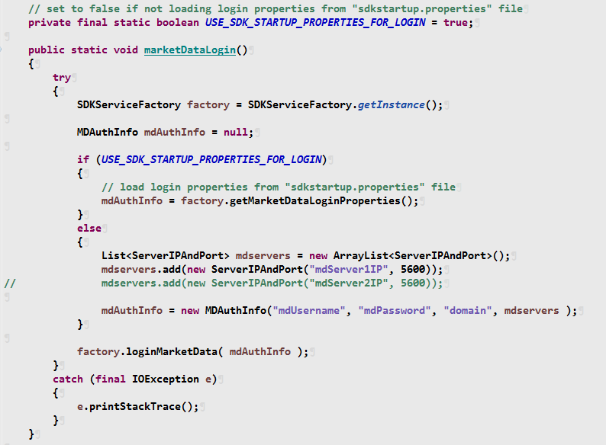

Here is an example Order Entry login.
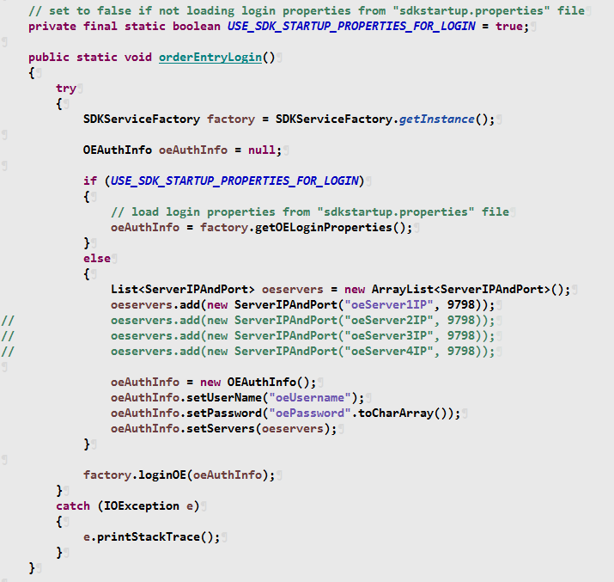

Disconnects
Market Data and Order Entry logins will automatically handle reconnects on disconnects. You do not need to code to relogin. However, not all “subscribed” services will refresh after a disconnect. You will need to make this part of your application development and testing plans.

Disable Nightly Shutdown
Also, the Neovest code that the SDK is built on does a nightly end-of-day shutdown. To disable this for SDK applications, use the following VM option.
-DoverrideEODShutDown=true

Javadoc
View the Javadoc by dbl-clicking the index.html file in the Javadoc directory. Here are the packages.
